Deployment and Monitoring of a Node.js Web Application on Windows using PM2 and GitHub

Virtual Private Cloud (VPC) :
VPC (Virtual Private Cloud) is a private, isolated network in AWS that allows you to securely run resources like EC2 instances.
You can control IP ranges, subnets, route tables, and gateways
Steps:
- Go to VPC Dashboard → Create VPC.
- Set IPv4 CIDR block (e.g., 10.0.0.0/16).
- Create subnets (public for EC2, private if needed).
- Create an Internet Gateway and attach it to your VPC.
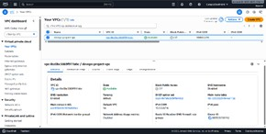
- Update route tables to allow internet access for public subnet

Launch an EC2 Instance
Go to EC2 Dashboard → Launch Instance. Choose windows
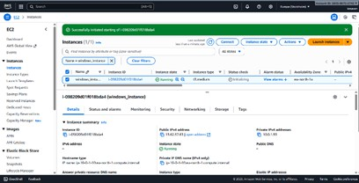
Attach the security group created

Create Project Folder
Command typed in Git Bash: mkdir web_project cd web_project

Initialize Node.js Project
Command in Git Bash:
git clone https://github.com/heroku/node-js-sample.git cd node-js-sample

Install Dependencies
Install necessary packages (like Express):
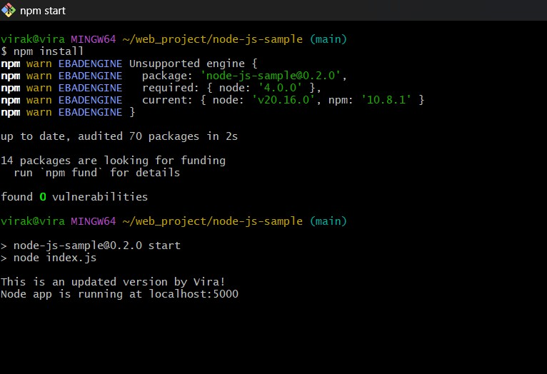
npm install

Modify the Code
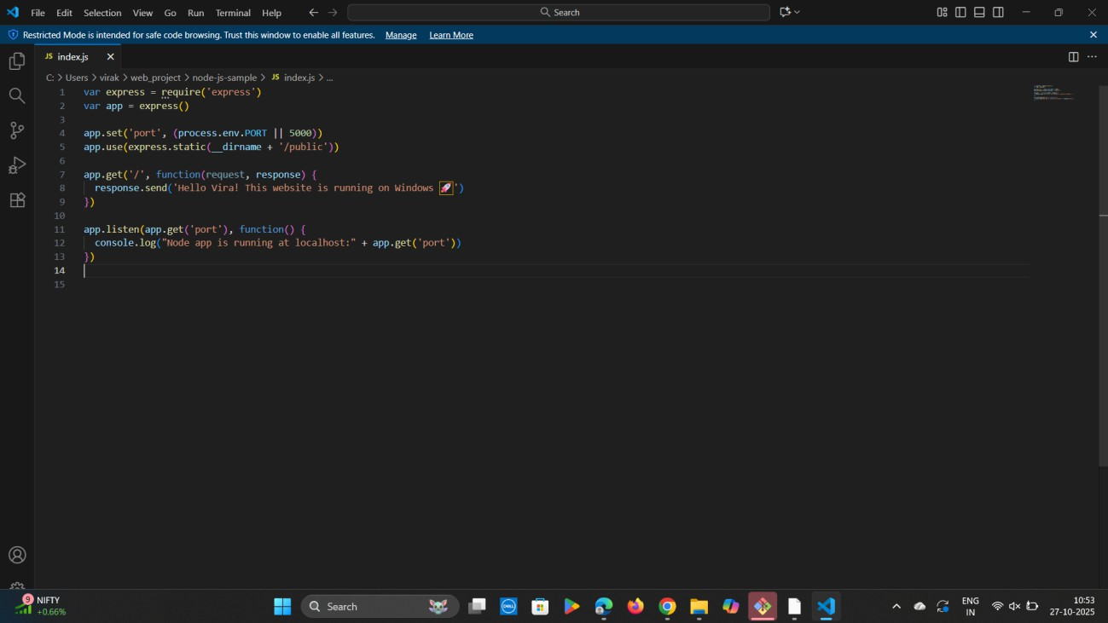
Open index.js file in VS Code and replace content with

Run the Application Locally

npm start

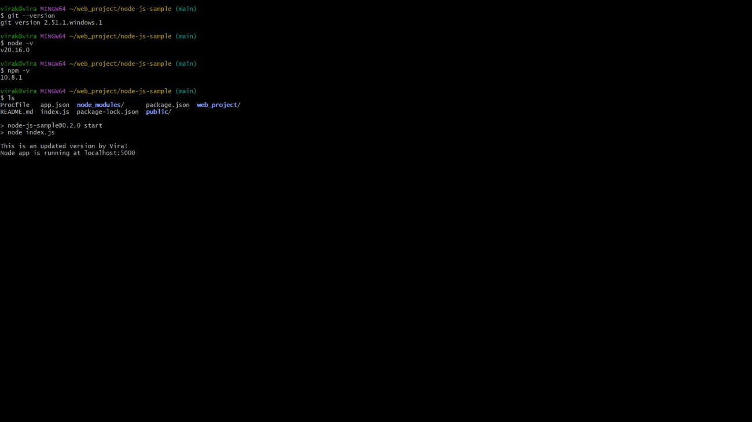
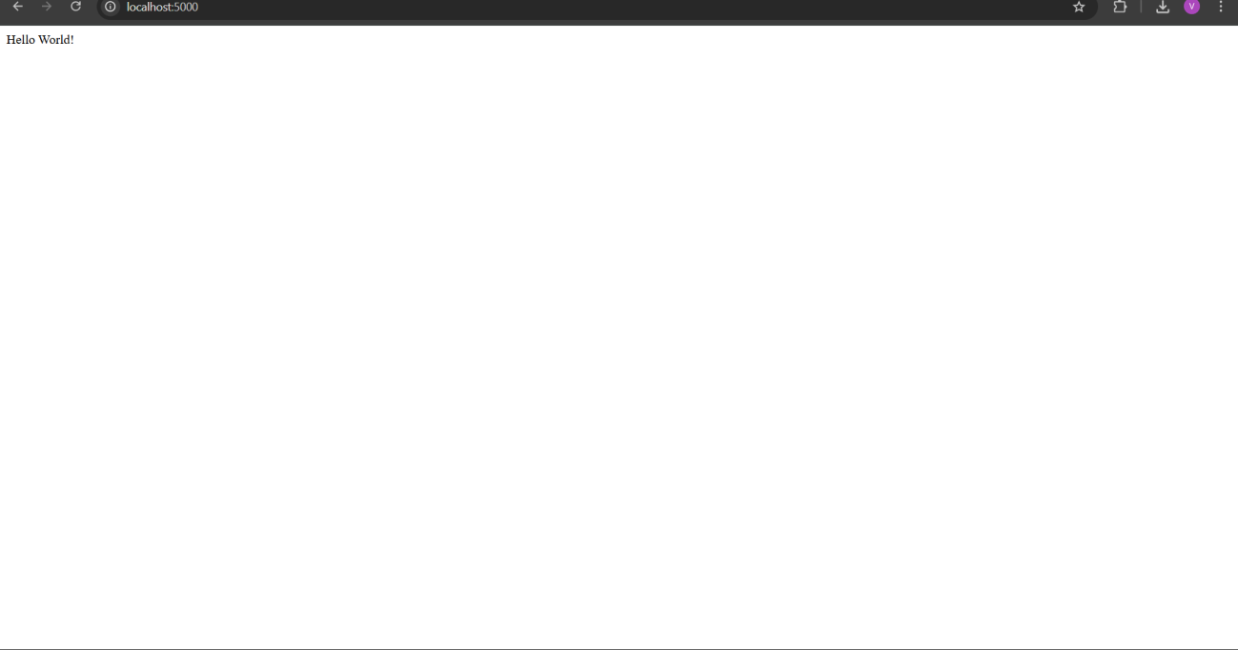

Initialize Git and Commit Changes

git init git add .
git commit -m "Updated homepage message for Windows version"

Create GitHub Repository

- Go to GitHub
- Click “New Repository”
- Name it: hello-vira-nodejs
- Set to Public
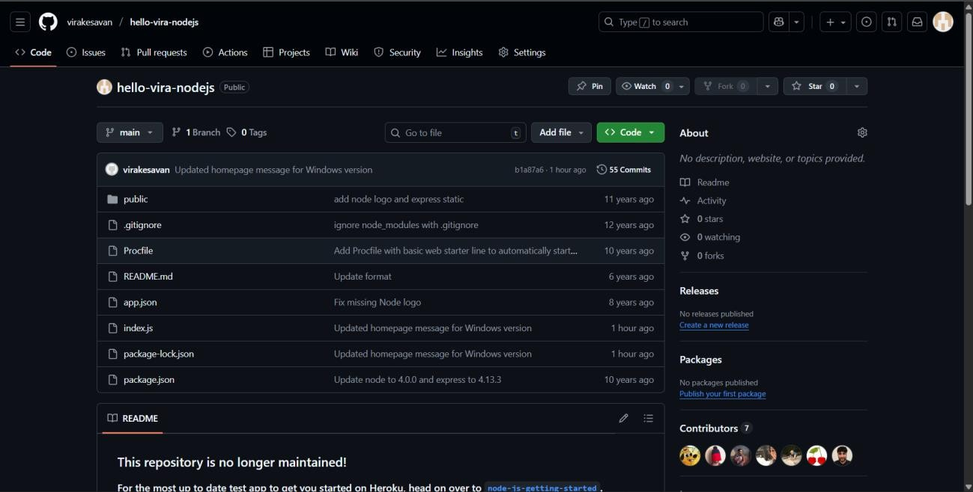

Connect Local Project to GitHub

git remote add origin https://github.com/virakesavan/hello-vira- nodejs.git
git branch -M main
git push -u origin main

We can see:
info: please complete authentication in your browser...

GitHub opens a Device Authorization page Enter the code shown in your terminal

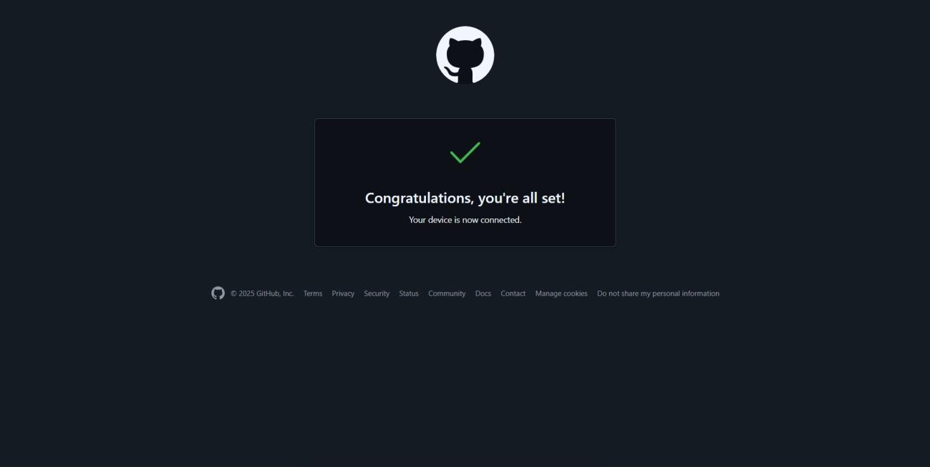
Click Authorize Git Credential Manager

Verify Upload on GitHub

After authentication completes:

- Refresh your repository page.
- You’ll see all files (index.js, package.json, etc.) uploaded.

Modify and Push an Update
- Make a new change in index.js
Example:
- console.log(This is anupdated versionby vira);

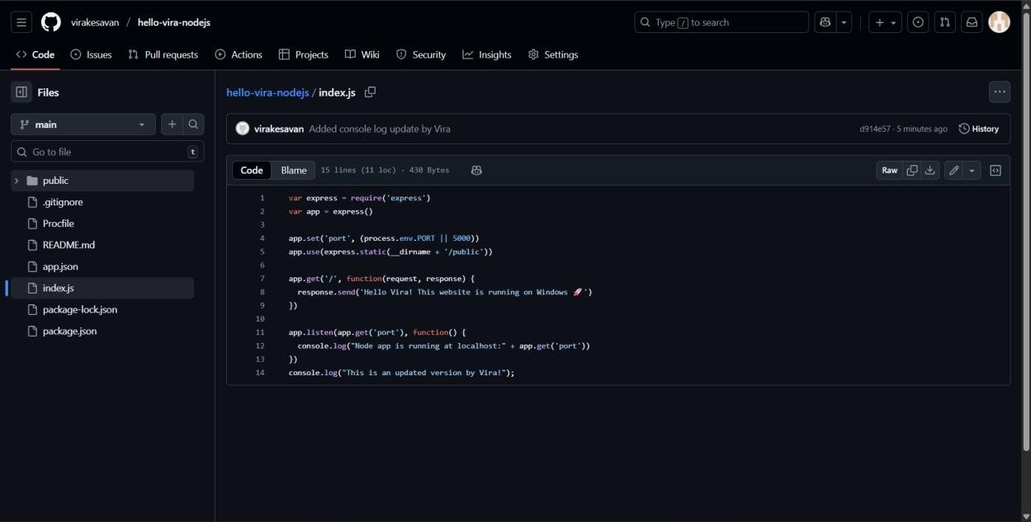

Then in Git Bash:
- git add index.js
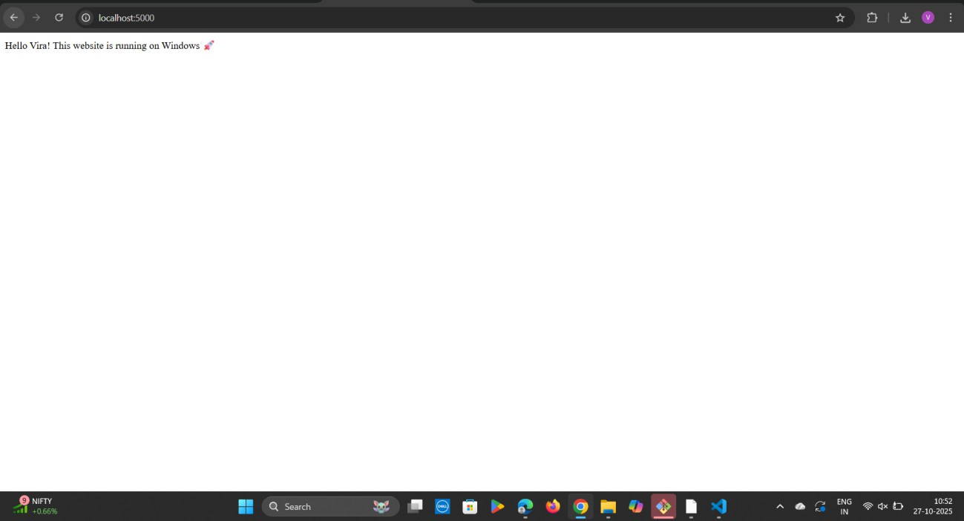
git commit -m "Added console log update by Vira" git push -u origin main

Conclusion
I have successfully:

- Set up Node.js and Git Bash on Windows
- Created a Node.js web app with Express
- Ran it locally at localhost:5000
- Linked and uploaded your project to GitHub
- Updated code, pushed commits, and verified changes

